Bank On Integrity
E-newsletter of the ICAC Corruption Prevention Network for Banks

February 2022

The COVID-19 outbreak and related anti-epidemic measures have dealt a heavy blow to businesses, in particular to local small and medium-sized enterprises (SMEs). In order to help businesses stay afloat and alleviate their cash-flow pressure, the Government launched a series of support measures to SMEs including the Special 100% Loan Guarantee for eligible enterprises. Since the launch of the scheme in April 2020, HKMC Insurance Limited has already approved over 45,000 applications through various lending institutions, involving an aggregate facility/guaranteed amount of over $77 billion.

While the banking sector has been supportive to the relief measures to help tide bank customers over difficult time, bank staff engaged in loan applications at the same time succumb to higher risk and new temptations in relation to the loan procedures. This issue of “Bank on Integrity” features a possible scenario relating to loan applications and reminds bank officers of their obligations under the Prevention of Bribery Ordinance (POBO) (Cap 201) and the relevant professional code of conduct. We will also highlight the “Ethics Promotion Programme for the Banking Industry” to be launched by the Hong Kong Business Ethics Development Centre (the Centre) of the ICAC in 2022.

Scenario
Bribery over Loan Application by bank staff

An SME proprietor besets with financial difficulties and wants to apply for loans from banks. She approaches a consultancy firm which claims to have strong connections with banks and can expedite the application process and secure bigger loans.

The director of the consultancy firm then submits false supporting documents of the SME, including the auditor’s report, bank statement and MPF record, to a bank officer with whom he has a close relationship. Although knowing that the documents are forged, the bank officer processes and recommends the application to his bank, falsely representing that all information contained in the documents is true.

Believing that all the documents submitted in relation to the application are genuine, the bank grants a loan of over $2 million to the SME. The SME proprietor then gives around 20% of the loan amount to the consultancy firm as “handling fee”, in which the bank officer received $20,000 rebate as a reward for his assistance.

Having succeeded once, the bank officer conspires with the consultancy firm to help a number of other SME clients to obtain loans from the bank. The scam is exposed after some SMEs’ defaults and the bank’s internal audit investigation.

iSir Notebook
- It is an offence under Section 9 of the POBO for an agent to accept any advantages as an inducement to, or reward for, his doing or forbearing to do any act in relation to his principal’s affairs.
- The bank officer, as an employee (agent) of the bank (principal), accepted rebates (advantage) from the consultancy firm as an inducement to or reward for processing and recommending loan applications (an act in relation to the bank). Without permission of the bank to accept the advantage, the bank officer contravened Section 9(1) of the POBO. The director of the consultancy firm also contravened Section 9(2) of the POBO for offering the advantage to the bank officer for the said purpose.
- It would also be an offence under Section 9(3) of the POBO for the bank officer (agent) to deceive/mislead the bank (principal) by using any application forms or supporting documents which contain false information.
- The bank officer might have also breached Sections 123 & 124 of the Banking Ordinance.
- Furthermore, the bank officer, the consultancy firm and the SME proprietors could be charged with fraud against the bank, or conspiracy to defraud the bank.

iSir’s Observations
- Corruption in the lending function may result in an increase in credit risks and bad loans, affecting the bank’s business and profitability. The fact that a customer is willing to offer a bribe in a loan application reflects both his possible financial problems and his poor integrity. His chance of defaulting repayment will be high.
- Some bank staff members may cross the line because of keen competition in the industry and pressure to secure loan business for the bank. In fact, over-reliance on bank staff to provide borrowers’ information without counterchecks increases the risk of manipulation.
- According to the requirements of the Hong Kong Monetary Authority, banks may proceed with a loan application referred by a third party (e.g. a consultancy firm) only if it is appointed by the bank, and that the prospective borrowers are not charged any loan-related fees by that third party in general. The bank should also obtain from its prospective borrower confirmation as to whether the loan application was referred by a third party, and if so, information on fees charged by the third party for referring such loan application.
- The bank officer who abused his authority for personal gains in the scenario seriously breached the trust placed on him by the bank. He may have to bear the legal consequences for having committed an offence under the POBO.

Good Control Practices
- With a stringent control mechanism of a bank, there is a good chance that the corrupt dealings will be detected. Good control practices include:
- separating credit approval authority from the staff who deal directly with customers;
- conducting vigilant due diligence, especially on high credit risk customers. For example, verify information provided by customers through the front desk office, and conduct reference check internally / externally;
- conducting regular assurance check to detect irregularities/unusual trend, such as a big jump in loan applications handled by a single bank officer within a short period of time.
- Banks should provide an independent, trustworthy and confidential channel for reporting malpractice, and encourage the staff to report any suspected corruption to the ICAC.
- Banks should report to the ICAC as soon as possible when corruption is suspected. Loud and clear top-level commitment to business ethics, professional integrity and zero tolerance of corruption drives ethical behaviour of an organisation and its members.

Ethics Promotion Programme for the Banking Industry
A sound, reliable and efficient banking system and financial market requires solid probity culture and high ethical standards of every banking practitioner. The Centre will launch the Ethics Promotion Programme for the Banking Industry in 2022/23 to promote professional ethics among banking practitioners, to enhance their understanding of the anti-bribery legislation and to help financial institutions fortify their integrity culture.

Major components include:
- New self-learning materials for frontline staff
- Updated practical guide for bank managers
- Integrity seminars for banking practitioners
- Sharing session(s) for members of Corruption Prevention Network for Banks

Stay tuned for our announcements!
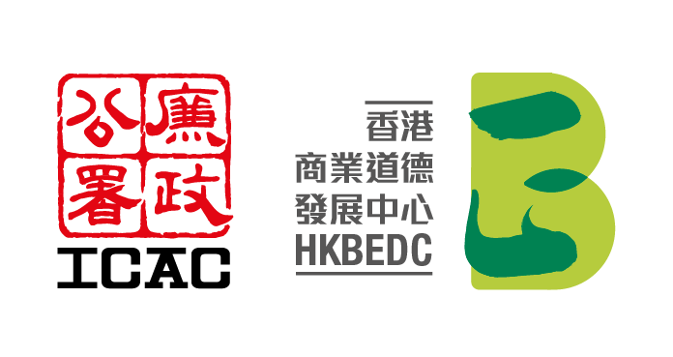
Subscribe to our e-news and follow our LinkedIn page for our latest training resources, news and activities.
Hong Kong Business Ethics Development Centre
Service Hotline: (852) 2826 3288
(Mon – Fri, 9am – 6pm, except public holidays)
E-mail: hkbedc@crd.icac.org.hk

* * *

HKMA’s circular, Engagement of Intermediaries by Authorized Institutions (30.11.2016) (https://www.hkma.gov.hk/media/eng/doc/key-information/guidelines-and-circular/2016/20161130e1.pdf)

